

# Perth College

### Semester Two Examination, 2017

### Question/Answer booklet

# YEAR 11

If required by your examination administrator, please place your student identification label in this box

# MATHEMATICS

**METHODS**

**UNITS 1 AND 2**

## Section One:

## Calculator-free

|  |  |  |  |  |  |  |  |  |  |  |
| --- | --- | --- | --- | --- | --- | --- | --- | --- | --- | --- |
| Student Number: In figures |  |  |  |  |  |  |  |  |  |  |

In words

Your name

## Time allowed for this section

Reading time before commencing work: five minutes

Working time: fifty minutes

## Materials required/recommended for this section

***To be provided by the supervisor***

This Question/Answer booklet

Formula sheet

***To be provided by the candidate***

Standard items: pens (blue/black preferred), pencils (including coloured), sharpener, correction fluid/tape, eraser, ruler, highlighters

Special items: nil

## Important note to candidates

No other items may be taken into the examination room. It is **your** responsibility to ensure that you do not have any unauthorised material. If you have any unauthorised material with you, hand it to the supervisor **before** reading any further.

## Structure of this paper

|  |  |  |  |  |  |
| --- | --- | --- | --- | --- | --- |
| Section | Number of questions available | Number of questions to be answered | Working  time (minutes) | Marks available | Percentage of examination |
| Section One:  Calculator-free | 8 | 8 | 50 | 52 | 35 |
| Section Two:  Calculator-assumed | 13 | 13 | 100 | 98 | 65 |
|  | | |  | **Total** | 100 |

## Instructions to candidates

1. The rules for the conduct of examinations are detailed in the school handbook. Sitting this examination implies that you agree to abide by these rules.

2. Write your answers in this Question/Answer booklet.

3. You must be careful to confine your response to the specific question asked and to follow any instructions that are specified to a particular question.

4. Additional working space pages at the end of this Question/Answer booklet are for planning or continuing an answer. If you use these pages, indicate at the original answer, the page number it is planned/continued on and write the question number being planned/continued on the additional working space page.

5. Show all your working clearly. Your working should be in sufficient detail to allow your answers to be checked readily and for marks to be awarded for reasoning. Incorrect answers given without supporting reasoning cannot be allocated any marks. For any question or part question worth more than two marks, valid working or justification is required to receive full marks. If you repeat any question, ensure that you cancel the answer you do not wish to have marked.

6. It is recommended that you do not use pencil, except in diagrams.

7. The Formula sheet is not to be handed in with your Question/Answer booklet.

Section One: Calculator-free 35% (52 Marks)

This section has**eight (****8)** questions. Answer **all** questions. Write your answers in the spaces provided.

Working time: 50 minutes.

Question 1 (7 marks)

(a) The tenth term of an arithmetic sequence is 67 and the fourteenth term is 51.

Determine the sum of the first 20 terms of the sequence. (4 marks)

(b) The geometric series $x, x^{2}, x^{3}, x^{4}…$ has a sum to infinity of $24$. (3 marks)

1. State the first term.
2. State the common ratio.
3. Determine the value of $x$.

Question 2 (5 marks)

(a) Determine $f'(x)$ if

(i) $f\left(x\right)={8x}^{5}-x+1$. (1 mark)

(ii) $f\left(x\right)={\left(3x+5\right)}^{2}$. (2 marks)

(b) The area of an oil spill, at time $t$ hours, is given by m2. Determine the instantaneous rate of change of area of the spill when $t=8$ hours.

(2 marks)

Question 3 (8 marks)

The graph of $y=ax^{3}+bx+c$ has a stationary point at $(2, 29)$ and a gradient of $18$ when $x=1$.

(a) Determine the values of the constants $a$, $b$ and $c$. (6 marks)

(b) Determine the coordinates of any other stationary points. (2 marks)

Question 4 (7 marks)

(a) Evaluate $x^{2a}÷x^{b}$ when $x=16$, $a=1.5$ and $b=3.5$. (3 marks)

(b) The first two terms of a geometric sequence are $1.5×{10}^{-2}$ and $3×{10}^{-5}$ respectively. Calculate the fifth term of the sequence, giving your answer in scientific notation. (4 marks)

Question 5 (7 marks)

Solve the following equations for $x$:

(a) $2\cos{x}=1, 0≤x≤360°$. (2 marks)

(b) $\begin{matrix}x-3 \\ \overline{x+2}\end{matrix}=\begin{matrix}2 \\ \overline{3}\end{matrix}$. (2 marks)

(c) ${\left(2x-3\right)}^{2}-36=0$. (3 marks)

Question 6 (5 marks)

(a) The graph of $y=f(x)$ is shown below, where $f\left(x\right)=\sqrt{x+1}$.

Add the graph $y=g(x)$, where $g\left(x\right)= \sqrt{x-1}+1$, to the axes. (2 marks)

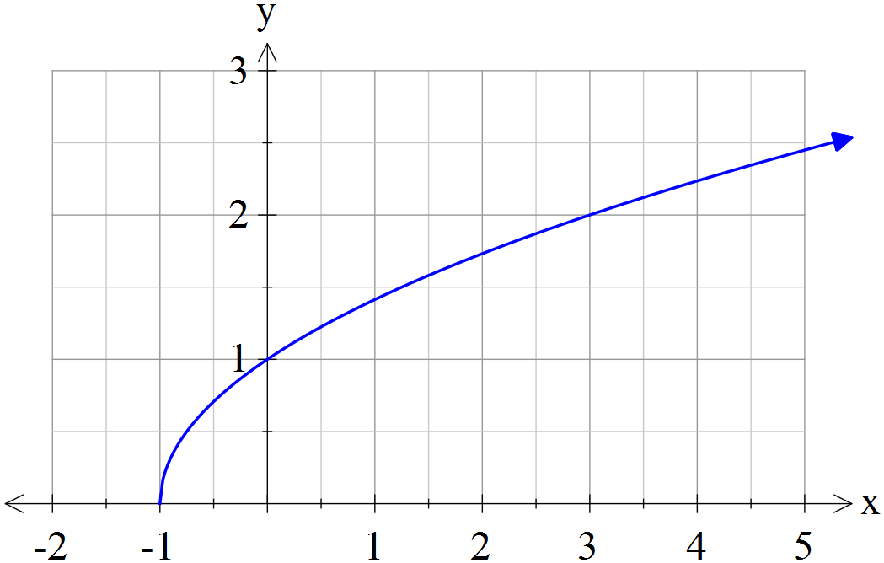

(b) Using first principles, find the value of the gradient of the curve $f\left(x\right)=x^{3}$ at the point where $x=5.$

(3 marks)

Question 7 (6 marks)

The graph of the function $y=f(x)$ is shown below, where

$$f\left(x\right)=\frac{5}{x-1}.$$

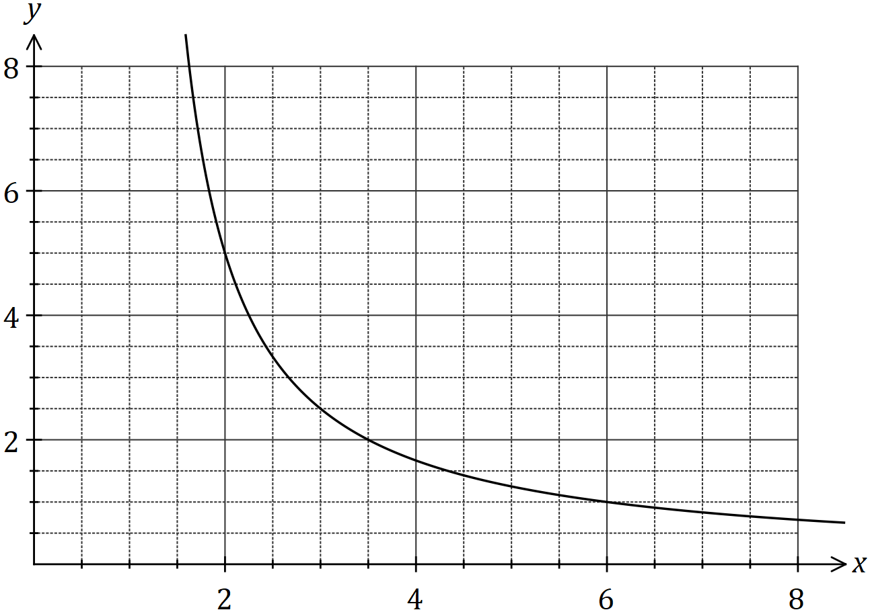

(a) Draw the tangent to the graph at $x=3$ so that it cuts both axes, and use the tangent to estimate the value of $f'(3)$. (3 marks)

(b) Calculate the average rate of change of the function as $x$ increases from $3$ to $3.5$.

(3 marks)

Question 8 (7 marks)

(a) Determine the coefficient of the $a^{3}$ term in the expansion of ${\left(2a-3\right)}^{4}$. (3 marks)

(b) Consider the equation $x^{3}-4x^{2}-11x+30=0$.

(i) Show that $x=2$ is a solution of the equation. (1 mark)

(ii) Determine all other solutions. (3 marks)

Additional working space

Question number: _________

|  |  |  |
| --- | --- | --- |
| Markers use only | | |
| Question | Maximum | Mark |
| 1 | 7 |  |
| 2 | 5 |  |
| 3 | 8 |  |
| 4 | 7 |  |
| 5 | 7 |  |
| 6 | 5 |  |
| 7 | 6 |  |
| 8 | 7 |  |
| S1 Total | 52 |  |
| S1 Wt (×0.6731) | 35% |  |
| S2 Wt | 65% |  |
| Total | 100% |  |